Description

**A list of what elements of the Unity engine are used：**

* Terrain (25%)

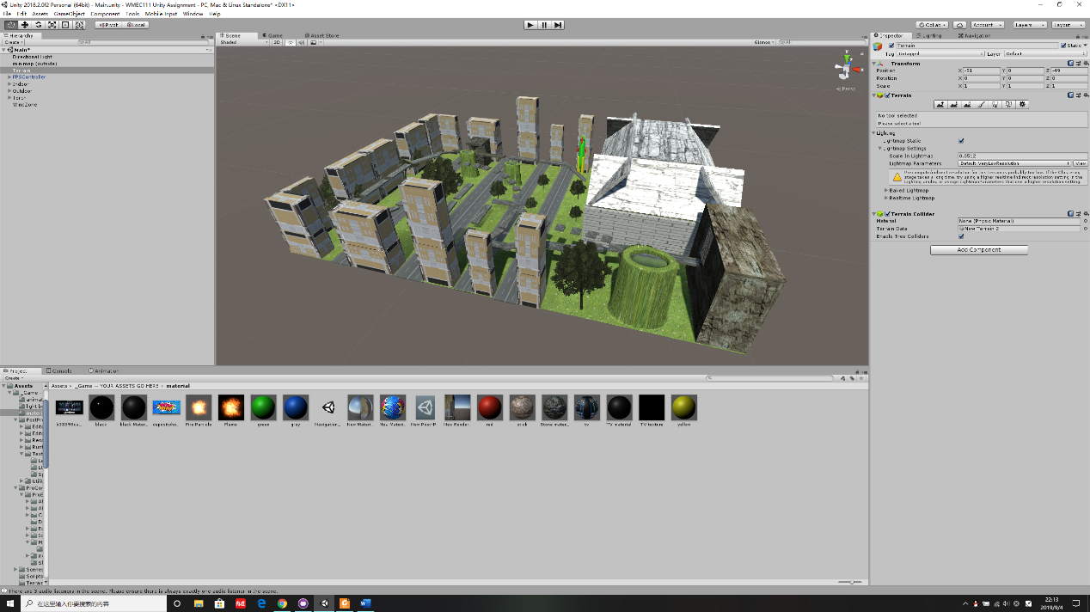

I was want to make a city zone on the mountain in GDD. However, a mountain will block the view of the road, so I converted the urban area to flat.

* Indoor section (25%)

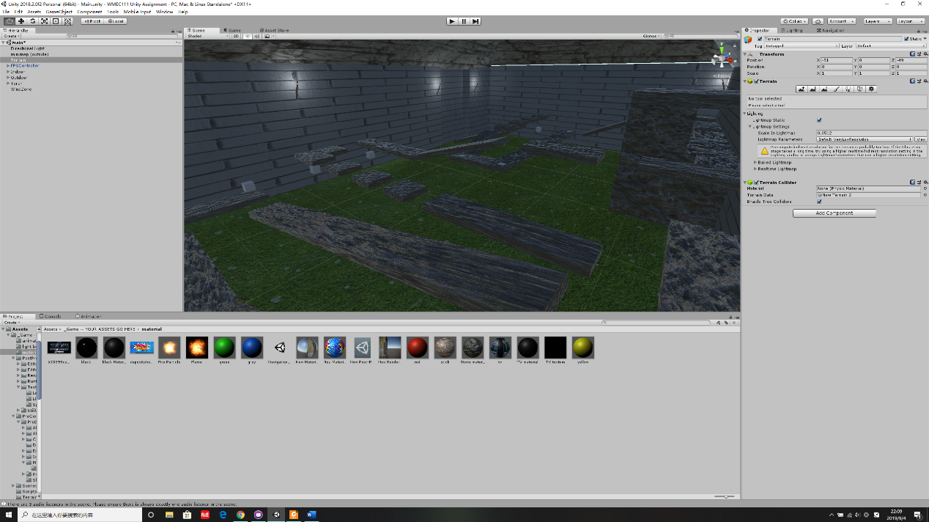

About indoor area, I wanted to make the interior area warm and bright in GDD. But I used a darker tone in final design, so that the game brings people to give more repression. In addition, I really don’t know how to make the monster described in the document, so I change the appearance of the monster.

* Appropriate textures on the indoor section and normal maps (10%)

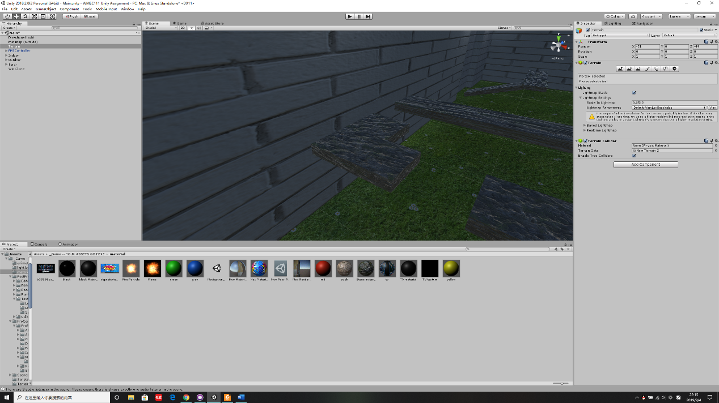

I want to use “Low Poly” as the GameObject for this game. But I didn't find enough low poly material, So I had to give up this idea.

* A simple single-state animation and a complex animation that responds to trigger (10%)

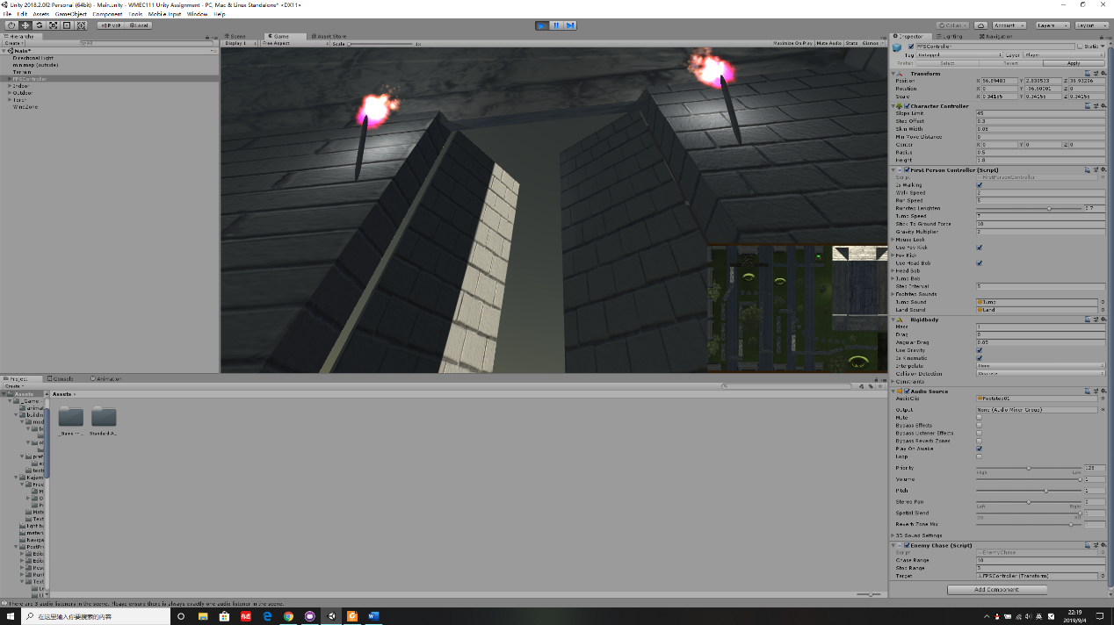

The effect of the door is same as described in the document. By the way, the production of automatic door connecting indoor and outdoor in the game has given me great challenges. But with the help of practice sheet and teachers, I finally succeeded in doing it.

* Direct light sources beyond the default Directional Light. Baked indirect lighting in the Indoor section. Use of light-probes for dynamic indirect lighting. Use of reflection-probes and reflective surface. Use of emissive materials (20%)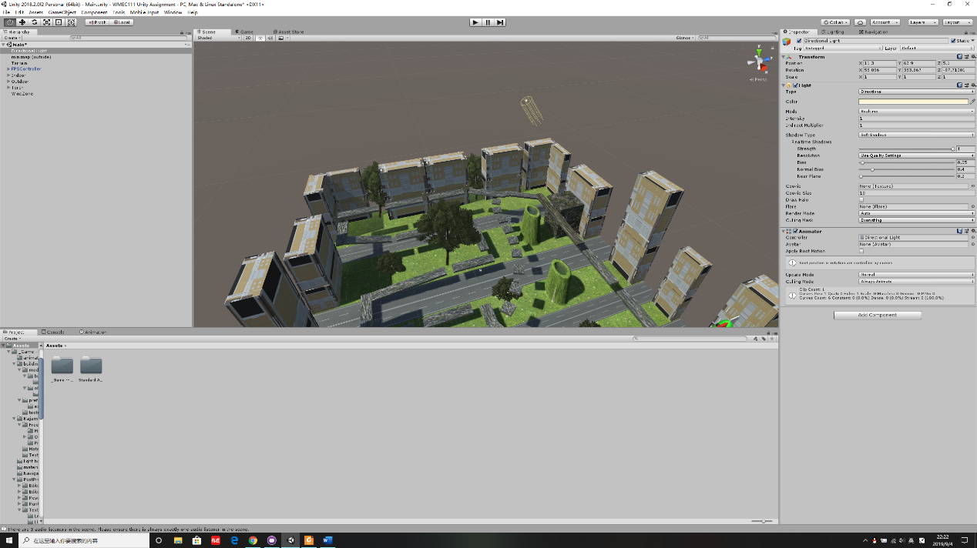

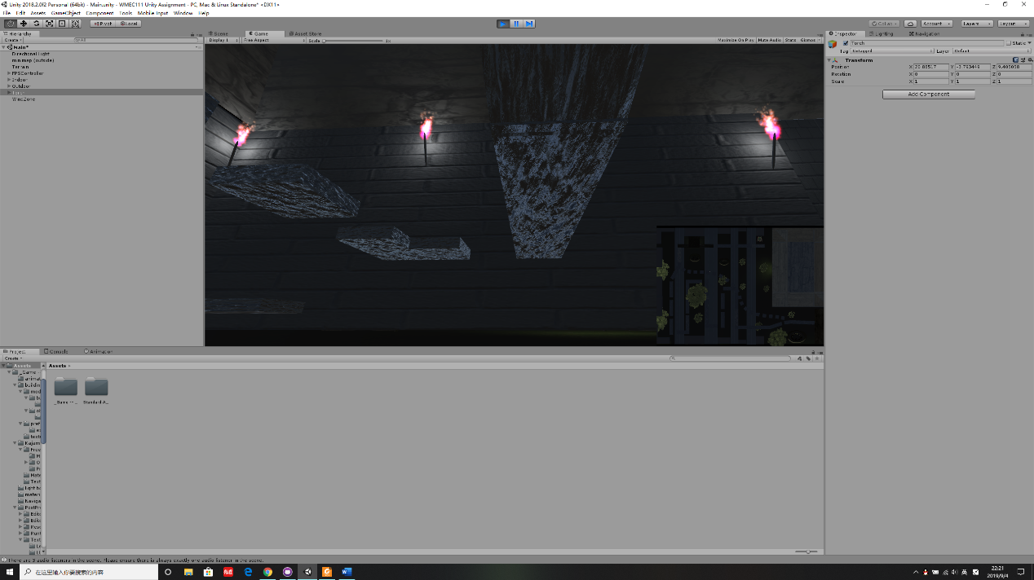

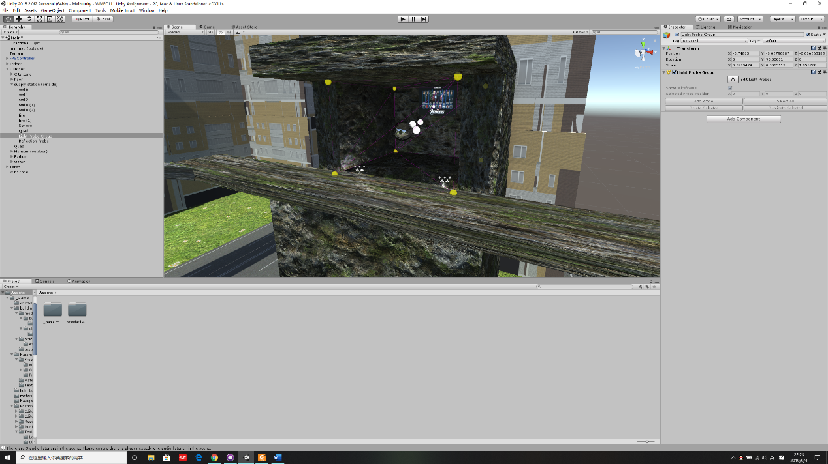

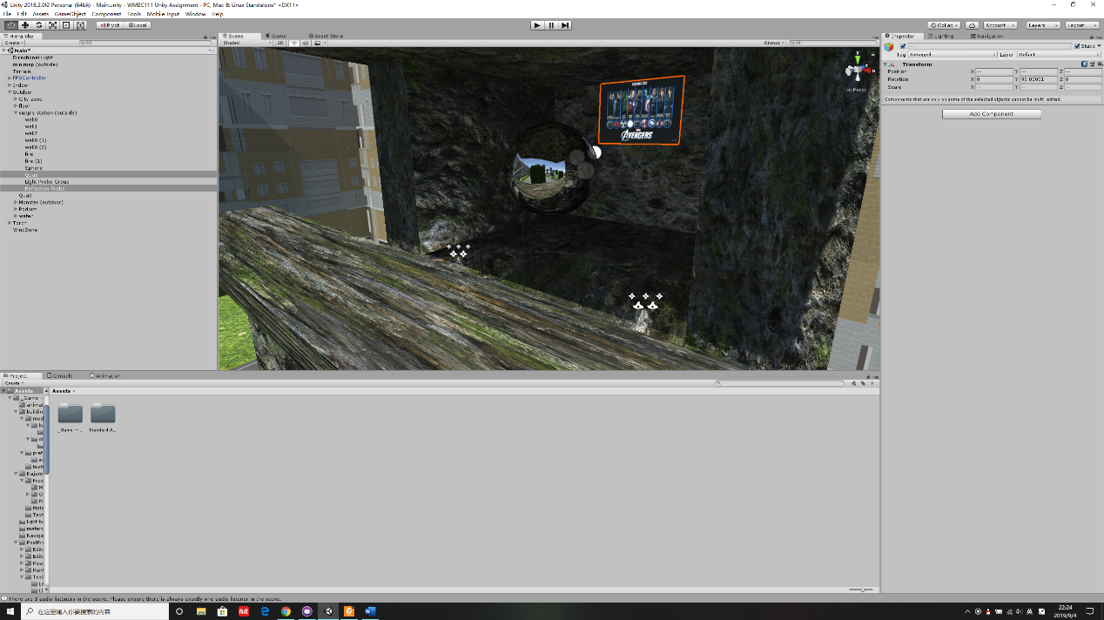

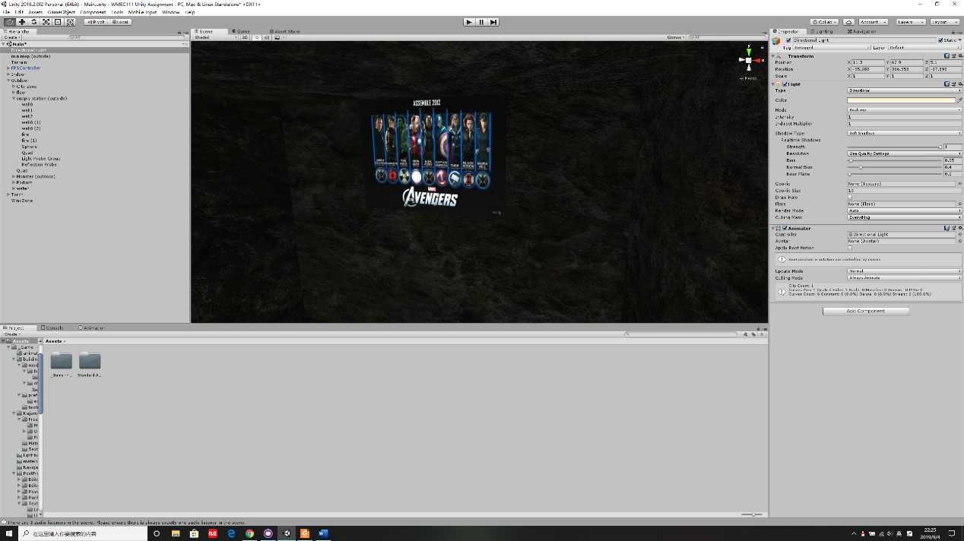

I added a supply depot background wall (emissive materials) and a reflector ball that is not described in the GDD.

* Appropriately applied effects via a post-processing stack (5%)

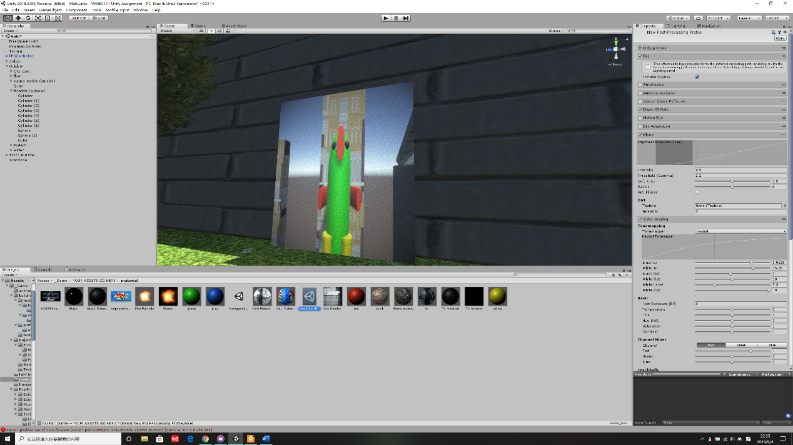

I added a player perspective screen and showed the TV snowflake effect that wasn’t described in GDD.

* Use of multiple cameras (10%)

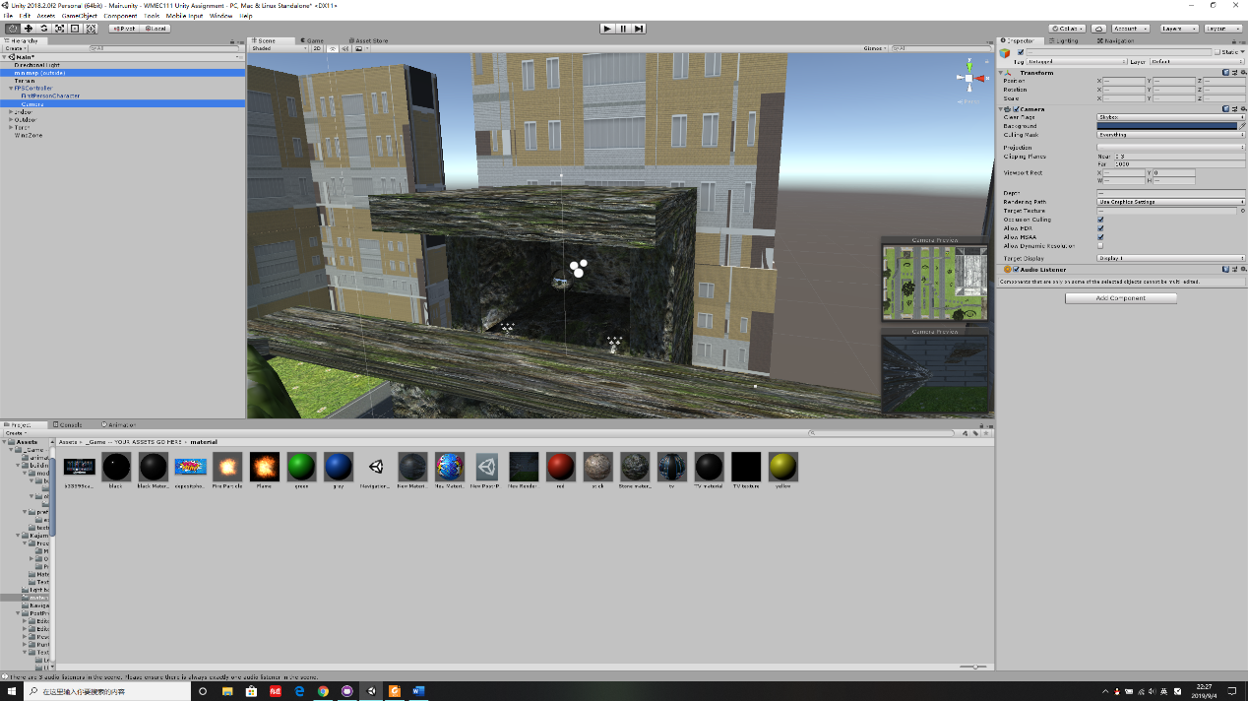

I added a player perspective screen and mini-map that wasn’t described in GDD.

* Particle effects (10%)

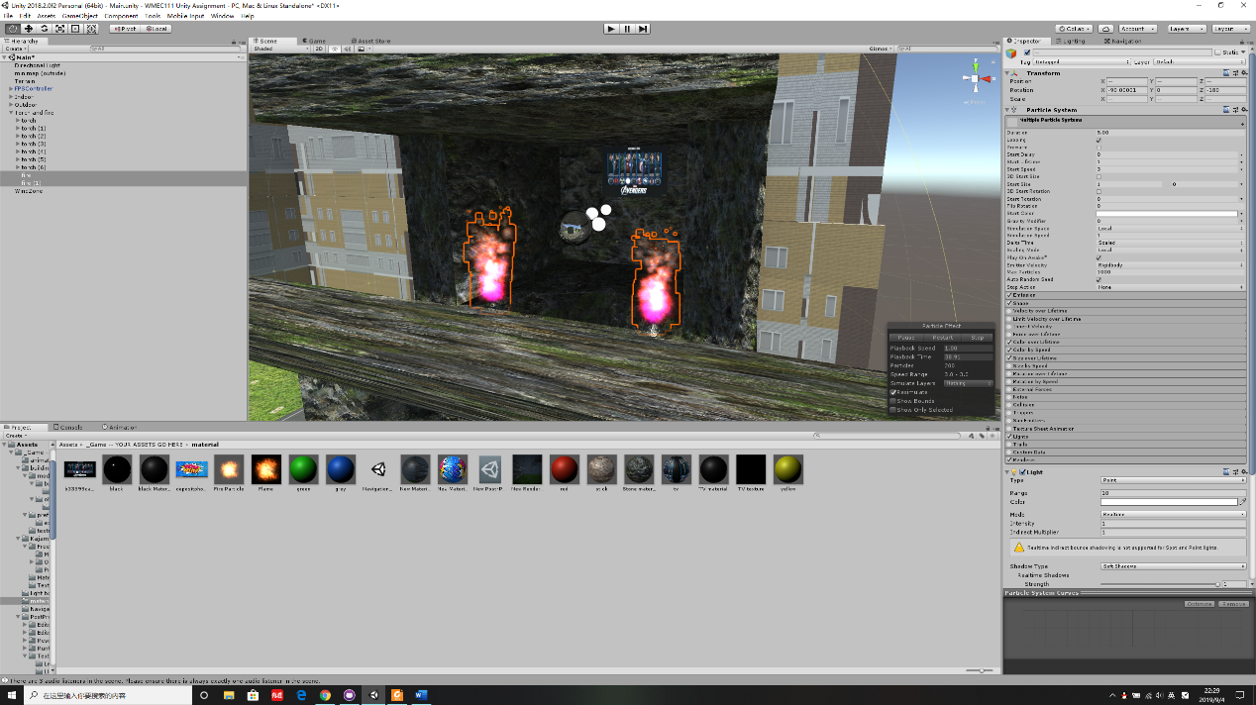

I added a flame effect which not described in the file.

* Objects controlled by physics and using joints (10%)

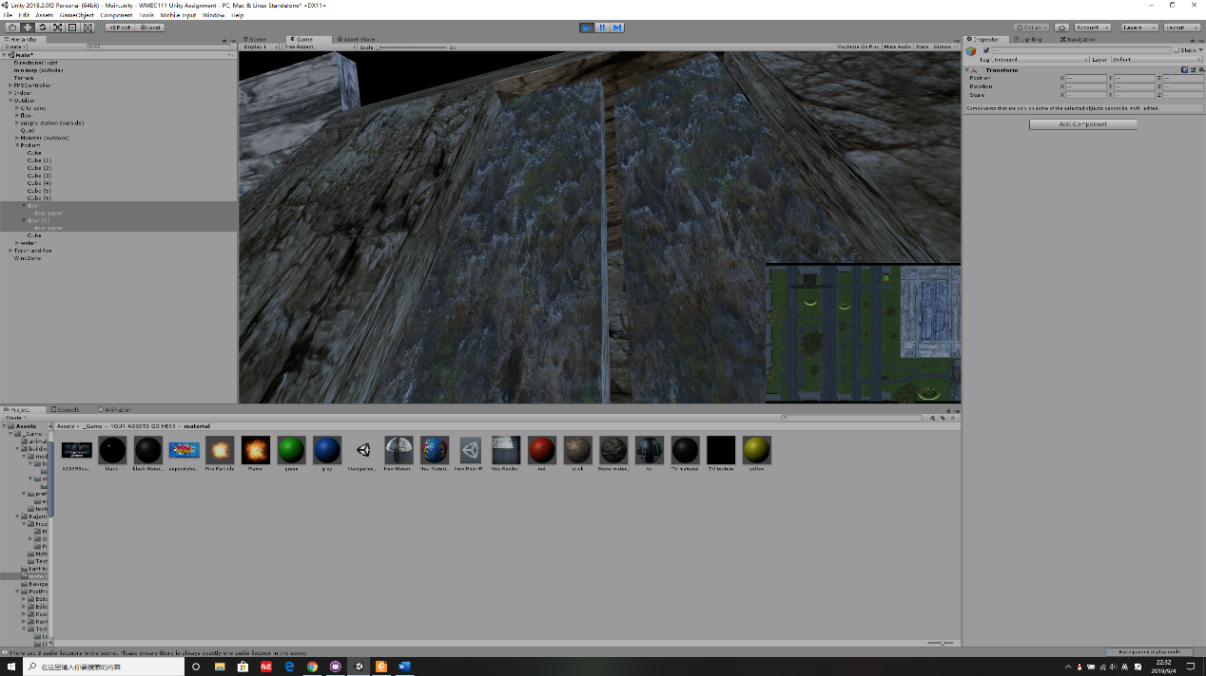

I added the physics of the second door that is not described in the file.

* Use of NavMesh Agents, using patrolling and chasing (10%)

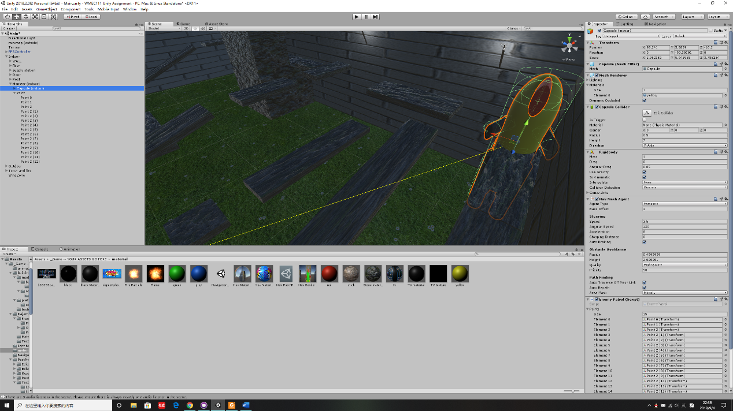

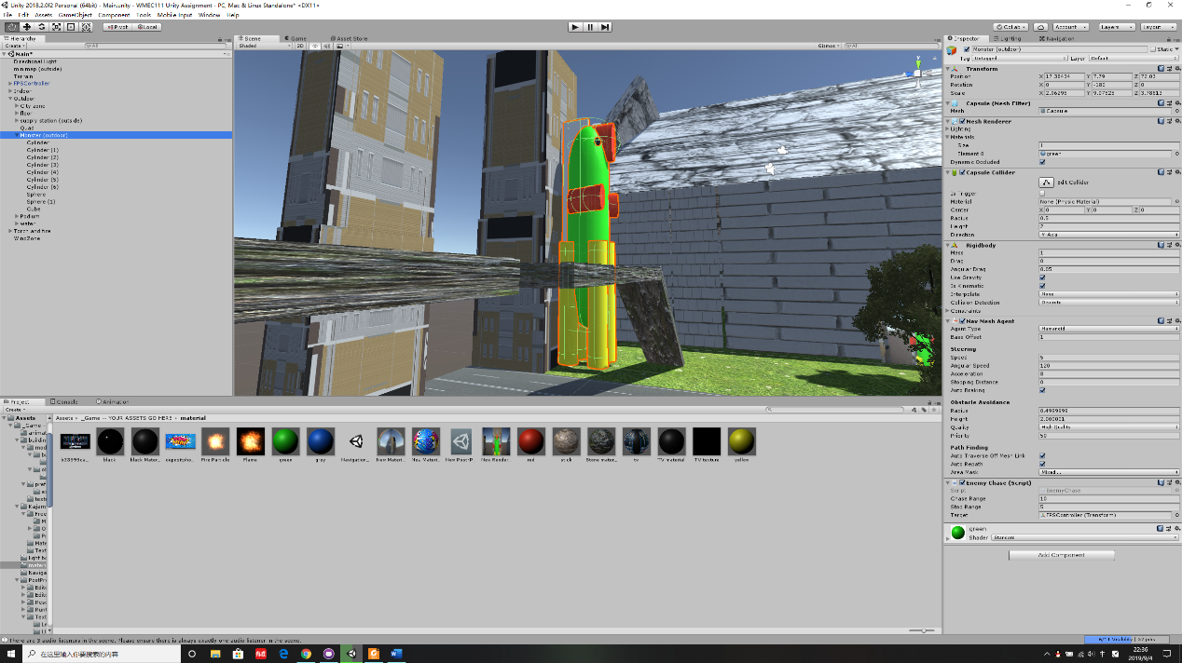

The indoor monster used patrolling and the outdoor monster used chasing, the final rendering of the monster is the same as described in the document.

**Reference:**

The texture of building in the outside section is used texture made by MIXAILL.

The texture of terrain and motorway is used texture made by KAJAMAN.